Deputy Head (Academic) – September 2019

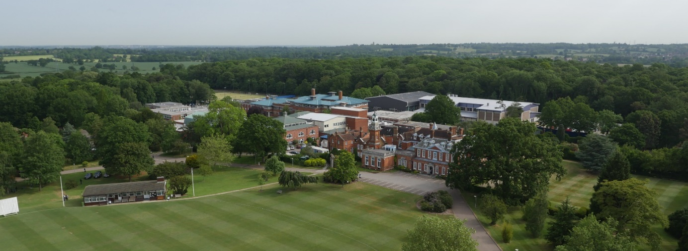

Following the promotion of the current post holder to the headship of a leading preparatory school, we are seeking an inspirational, strategic and impactful school leader, with an excellent understanding of the primary sector, a track record of leading outstanding teaching and learning in a high achieving environment and of implementing whole school initiatives.
We are looking for a role model for pupils and colleagues, a leader who will deliver a world-class prep education for our bright boys by ensuring that: teachers’ practice, their development and self-reflection is exceptional, that the boys are challenged and excited by an educational provision consistent with emerging needs, and that their progress is outstanding.
The Deputy Head (Academic) leads all daily aspects of teaching and learning in the Prep School and more broadly shares with the Deputy Head (Pastoral) and the Senior Teacher the management of the School’s operations. As a member of a collegial leadership team (PLT) comprising the Head of Prep, Head of Pre-Prep, Deputy Head (Pastoral) and Senior Teacher, the Deputy Head (Academic) also shares the strategic leadership and development of the school and will regularly deputise for the Head.
The post would suit an ambitious candidate aspiring for headship in a few years’ time.

Applications
If you wish to discuss this post informally, please contact the Head of the Preparatory School, Mr Matteo E Rossetti, on 020 8266 1779
An application form is available from the School’s website: www.habsboys.org.uk. Curriculum Vitae are not accepted.
The School is also advertising for a Deputy Head (Pastoral) due to the retirement of the current post holder; candidates should apply for both roles separately.
The completed application form should be sent to the Human Resources Manager (staffvacancies@habsboys.org.uk) as soon as possible (preferably electronically). It must be received no later than noon on Monday 28th January 2019. We intend to interview for this post during the week commencing Monday 4th February 2019.

The Preparatory and the Pre-Preparatory Schools

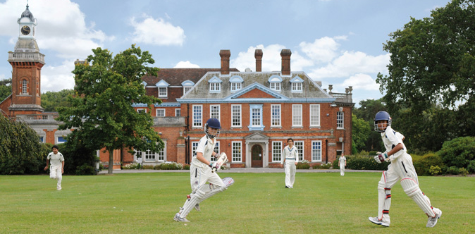
The Haberdashers’ Aske’s Boys’ Preparatory School (‘the Prep’) aims to nurture excellence within its established values of wisdom, integrity and humility. It seeks to inspire curiosity in bright boys, underpinning it with rigorous skills, to challenge them in and out of class in a warm and supportive environment and to instil in them a strong sense of service and dedication to their community. The members of the Schools’ teaching staff are united by a caring approach, passion for their subject areas and the aspiration to be dynamic, modern and reflective practitioners. The boys are bright, articulate and open, curious and extremely rewarding to teach. They have a great sense of humour and are very well mannered.
As the top performing boys’ preparatory school between 2006 and 2015, and The Sunday Times Prep School of the Year in 2011 and 2006, the Prep enjoys an outstanding reputation and is the academic school of choice for bright boys in North London and beyond.
The Prep has its own newly refurbished purpose-built premises and shares the excellent facilities of the Senior School.
There are twelve classes of approximately 18 boys in the Prep. Highly able, enthusiastic, and motivated, boys participate to an impressive level in a broad range of extra-curricular activities. Chess and music are a strength. HABS’ pupils regularly reach the finals of the All-England Athletics and IAPS Swimming and Judo Championships and the strength of School music is attested by concerts given at the Barbican and the Albert Hall.
The Prep curriculum is broadly-based on the National Curriculum and enhanced further with languages (Latin, French, Arabic and Russian), linguistics, theology and philosophy, art and design and a first-rate Forest School programme. In Years 3 and 4, teaching is largely classroom-based with additional specialists who teach Music, PE, and RS. All subjects in Year 5 and 6 are taught by subject specialists.
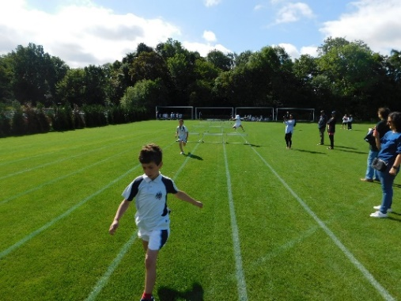
The School is oversubscribed and in September 2007 Governors opened a new Pre-Preparatory (Pre-Prep) School in an idyllic woodland setting just south of St Albans, six miles from the Prep and Senior School site. The Pre-Prep currently serves 72 boys aged from five to seven, in two year 1 and two year 2 classes.
Entry to The Pre-Prep is highly competitive and the standard of academic work is high. The curriculum is based on the Key Stage 1 National Curriculum which is enriched by additional materials, resources and the individual teacher’s personal knowledge and interests. The Pre-Prep staff frequently join staff from The Prep for professional training and there are regular meetings between The Pre-Prep Head and The Prep Subject Co-ordinators. The Pre-Prep make frequent visits to the Prep/Senior School site in Elstree for Games lessons and to join in various activities. It is expected that the Deputy Head (Academic) would work closely with the Head of Pre-Prep, who is line-managed by the Head of Prep School.

The Senior School

The Prep shares with The Haberdashers’ Aske’s Boys’ School (‘HABS’) its 100-acre rural site occupying the grounds of a former stately home, Aldenham House, a Grade 2* listed building. A series of magnificent new buildings have been opened in the last decade, including a £13m Sports Facility in 2016 and there are plans for considerable new investment in further development of the site.
HABS has an international reputation for academic excellence and success, combined with exceptional pastoral care and extra-curricular achievements. The school is regularly placed at the top of the national league tables, places are heavily oversubscribed, and entry is extremely competitive. Boys achieve national prominence in many fields, from music, drama and sport to science and Mathematics Olympiads, chess and public speaking.
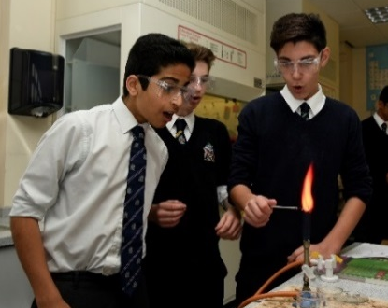
Pastoral care is exceptional, with a strong House-based system. Out-of-class activities abound, with many boys assuming responsibility for the running and organisation of events and societies. Music, drama and sport are strong, and there are also thriving Outdoor Leadership and CCF programmes together with a strong and active Community Service programme. There is a remarkable commitment to outreach and charity work, reflecting the rich and harmonious ethnic and religious diversity of the School. A Church of England School by tradition, other religious communities flourish with popular, voluntary assemblies on Thursday mornings for the many different faith groups which are represented in the School.

The School awards a number of scholarships on entry, but the majority of its funding goes into the provision of bursaries for cases of financial need, echoing the founding philosophy of Robert Aske. A very successful Development Foundation exists to broaden participation in the life of the School and encourage philanthropic giving.

Though the Prep is a distinctive entity from HABS Senior School, with its own DfE number and inspected separately, the Prep School is closely linked to the Senior School and it is the strategic intent of the Governors to increase those links. The Head of Prep serves on HABS’ Senior Management Team and is line-managed by the Headmaster.
More detailed information about the School and its history is available on the School website: www.habsboys.org.uk and through the Good Schools Guide www.goodschoolsguide.co.uk

The Teaching Staff

The members of the HABS Schools’ teaching staff are drawn from a wide range of backgrounds and reflect the diversity within the Schools. All are well qualified and have strong subject knowledge with a deep sense of commitment to the welfare of the boys and to help them achieve their very best. There is a strong sense of community within the Common Rooms, which are harmonious and dynamic places where staff work hard in a collaborative and purposeful atmosphere. There is a growing international dimension to the work of staff with regular visits overseas and links with the best schools across the globe.
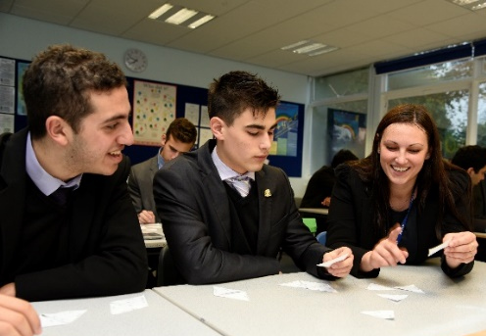
Support for staff at every stage of their career is exceptional, with one of the foremost and forward-thinking professional development plans in the country. Pedagogy and teacher development takes a collaborative approach which is both voluntary and open-minded. Many teaching staff attend Learning Lunches where their peers will demonstrate new developments or ideas with which they have been experimenting. In addition, teachers can request specific training which is often run in well attended Twilight Training sessions at the end of a school day. The School operates an ‘open door’ approach with teachers regularly observing and learning from each other.
Every member of the teaching staff is expected to participate in the School’s rich array of co-curricular and sporting subjects. The main sports are rugby, hockey, football, athletics and cricket and the magnificent new swimming pool facility is raising the profiles of swimming and water-polo. Members of the teaching staff lead over 60 clubs and societies which include outreach programmes and charity fundraising projects. HABS will always encourage members of staff to share and support appropriate interests.

The Vacancy
The post will suit an inspiring, creative and highly able primary school leader who wishes to take the next step in their career in an extremely high achieving environment. The successful candidate will have a passion for teaching and learning, demonstrable experience of inspiring curiosity in bright boys and an excellent understanding of the national primary and/or prep sectors.
They will be able to:
- Participate in the strategic leadership and operational management of the school and in its development;
- Lead the fostering of a learning culture amongst staff, with excellent reflection and professional development opportunities;
- Ensure that the education provision is consistent with emerging curriculum requirements;
- Ensure that the progress of students is outstanding, also by tracking and monitoring formal and informal data.
The role holder is expected to demonstrate the follow attributes:
- Experience of school management at a senior level within a highly successful independent preparatory school or state primary school;
- Outstanding classroom practice, with QTS, as well as experience in leading the development of excellent teaching in others;
- A sharp intellect to dissect problems and the creativity and positivity to identify solutions;
- Excellent organisational skills and a keen eye for detail;
- Team spirit, emotional intelligence, approachability, flexibility and resilience.
This is an exciting time in the history of HABS, with a newly appointed Headmaster and Head of Prep, a strategic drive towards ever closer collaboration between their schools and Haberdashers’ Aske’s School for Girls, which occupies the adjacent site, and the development of the Elstree campus over the next ten years. For this reason, candidates who are creative, energetic and impactful will be particularly welcome.
Applications are invited from teachers in either the maintained or independent school sector.
The post holder will line-manage Phase Leaders, Heads of Department and Subject Co-ordinators and will be line managed by the Head of Prep, for whom he or she will deputise regularly.
The successful candidate will be expected to teach a portion of a timetable, and to contribute to the co-curricular programme. The nature of this post might require the successful candidate to be present at the Prep and Pre-Prep before and beyond the timetabled day, at evening and weekend functions and beyond term time.

Principal Duties
To be read in conjunction with the terms of employment.
The Deputy Head (Academic) will be a member of the Prep Leadership Team (‘PLT’) and hold broad operational and strategic responsibility for the management of The Prep, its development and curriculum. The Deputy Head (Academic) may be asked to deputise for the Head of The Prep and will be expected to work seamlessly with The Deputy Head (Pastoral).
The responsibilities of this post are likely to include, but are not restricted to:
Strategic School Aims and Objectives
- Work closely with the rest of the Prep Leadership Team (‘PLT’) to develop and monitor the strategic direction of the Prep School, also collaborating with colleagues in the Senior School and Girls’ School to ensure a shared vision;
- Assist in the preparation, promotion and implementation of School policies;
- In conjunction with PLT and particularly the Deputy Head (Pastoral), oversee discipline in the Prep and the Pre-Prep;
- Lead colleagues on the Prep teaching staff to do their work as effectively as possible.

Staff Development
- Lead, monitor and develop the quality of teaching in the Prep School, so that it is consistently excellent;
- Design and coordinate staff development in the Prep School, in collaboration with HABS’s Director of Teaching, so that the Prep school provides world-class professional development;
- Assist with staff’s annual review and performance management.
Curriculum and Timetable
- Design the curriculum in collaboration in the Head of Prep and other members of PLT;
- Monitor and evaluate the curriculum and its delivery across the Prep and the Pre-Prep Schools;
- Have responsibility for meetings with Phase Leaders, Heads of Department and Subject Co-ordinator;
- In collaboration with the Senior Teacher, create the Prep timetable and co-curricular timetable. Ensure both of these are constructed to provide balance and promote the Schools’ values;
- Have responsibility for the duty rotas and duties with The Prep.
Academic Monitoring and Assessment
- Lead the tracking, evaluation and feedback of the performance of pupils in the Prep School and ensure the progress of each pupil;
- Lead the detailed statistical analysis of different aspects of the Prep and the Pre-Prep throughout the year and appropriate publication of this information, as required, both internally and externally;
- Work with the Academic Support Teacher in the Prep and the Pre-Prep to ensure relevant pupils are assessed and their support is created, implemented and documented.
Any other reasonable and related activities at the discretion of the Head of the Preparatory School or the Headmaster.
Salary and Benefits
The School has its own generous salary scale, supplemented by a performance-related scheme. The salary for the successful candidate will depend upon their qualifications and experience and will be discussed at interview.
Candidates should note that all appointments are subject to an enhanced check with the Disclosure & Barring Service and references from past employers.
Benefits
Currently the School offers a wide range of benefits to teaching staff, including:
- A strong commitment to professional development, with a substantial budget for whole school training and individual courses. Support is given for sabbaticals, post-graduate degrees and other relevant qualifications;
- Membership of the Teachers’ Pension Scheme (TPS);
- Group Life Assurance (4 x salary);
- Fee Remission of 66% for each eligible child at the Boys’ and Girls’ Schools who is offered a place;
- Reimbursement of relocation expenses;
- Childcare Vouchers;
- Free sports clothing for those taking games;
- Free lunches, other meals and refreshments;
- Free parking on the School campus;
- Free coach travel on the service provided by the School (subject to availability);
- Free use of a laptop computer or tablet device;
- Tax free bicycles for work through the Cycle to Work Scheme;
- Free use of the state-of-the-art Medburn Centre including fitness suite, swimming pool and squash courts, including free training programmes and advice from the School’s Fitness Coach;
- Access to the School Counsellor.

We look forward to receiving your application.
Matteo E Rossetti
Head of Prep School

