Deputy Head (Pastoral) - September 2019

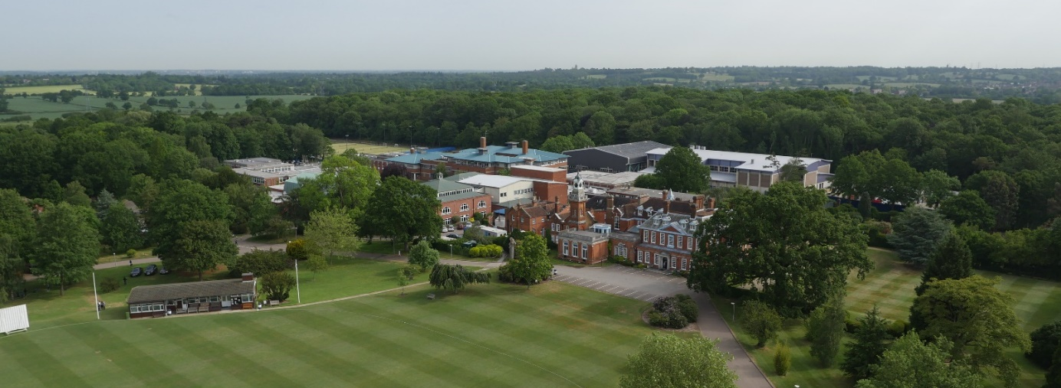

Following the retirement of the current post holder and the Deputy Head’s (Academic) promotion to headship of a leading preparatory school, we are seeking an inspirational, strategic and impactful school leader, with a sophisticated understanding of pastoral care in the primary sector and a track record of fostering the wellbeing and flourishing of pupils which is likely to have been gained in a high achieving environment.
We are looking for a role model for pupils and colleagues, a leader who will ‘nurture excellence’ in our boys by delivering a world-class pastoral programme. The ideal candidate will recommend and implement innovations from research and practice in pastoral provision, lead the development of pupils’ character and wellbeing, their safeguarding and the care and wellbeing of Prep staff.
The Deputy Head (Pastoral) leads all daily aspects of pastoral care in the Prep School and more broadly shares with the Deputy Head (Academic) and the Senior Teacher the management of the school’s operations. As a member of a collegial leadership team (PLT) comprising the Head of Prep, Head of Pre-Prep, Deputy Head (Academic) and Senior Teacher, the Deputy Head (Pastoral) also shares strategic leadership and development of the school and will regularly deputise for the Head.
The post would suit an ambitious candidate aspiring for headship in a few years’ time.
Applications
If you wish to discuss this post informally, please contact the Head of the Preparatory School, Mr Matteo E Rossetti, on 020 8266 1779.
An application form is available from the School’s website: www.habsboys.org.uk. Curriculum Vitae are not accepted.
The School is also advertising for a Deputy Head (Academic) due to the promotion of the current post-holder to the Headship of another school; candidates may apply for both roles separately.
The completed application form should be sent to the Human Resources Manager (staffvacancies@habsboys.org.uk) as soon as possible (preferably electronically). It must be received no later than noon on Monday 28th January 2019.
We intend to interview for this post the week commencing Monday 4th February 2019.

The Preparatory and the Pre-Preparatory Schools

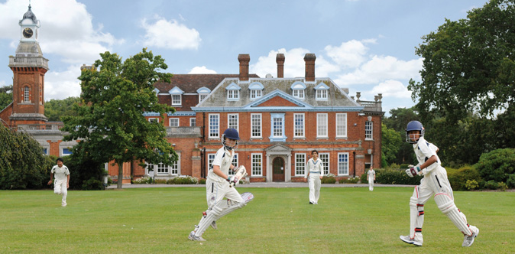
The Haberdashers’ Aske’s Boys’ Preparatory School (‘the Prep’) aims to nurture excellence within its established values of wisdom, integrity and humility. It seeks to inspire curiosity in bright boys, underpinning it with rigorous skills, to challenge them in and out of class in a warm and supportive environment and to instil in them a strong sense of service and dedication to their community. The members of the Schools’ teaching staff are united by a caring approach, passion for their subject areas and the aspiration to be dynamic, modern and reflective practitioners. The boys are bright, articulate and open, curious and extremely rewarding to teach. They have a great sense of humour and are very well mannered.
As the top performing boys’ preparatory school between 2006 and 2015, and The Sunday Times Prep School of the Year in 2011 and 2006, the Prep enjoys an outstanding reputation and is the academic school of choice for bright boys in North London and beyond.
The Prep has its own newly refurbished purpose-built premises and shares the excellent facilities of the Senior School.
There are twelve classes of approximately 18 boys in the Prep. Highly able, enthusiastic, and motivated, boys participate to an impressive level in a broad range of extra-curricular activities. Chess and music are a strength. HABS’ pupils regularly reach the finals of the All-England Athletics and IAPS Swimming and Judo Championships and the strength of School music is attested by concerts given at the Barbican and the Albert Hall.
The Prep curriculum is broadly-based on the National Curriculum and enhanced further with languages (Latin, French, Arabic and Russian), linguistics, theology and philosophy, art and design and a first-rate Forest School programme. In Years 3 and 4, teaching is largely classroom-based with additional specialists who teach Music, PE, and RS. All subjects in Year 5 and 6 are taught by subject specialists.
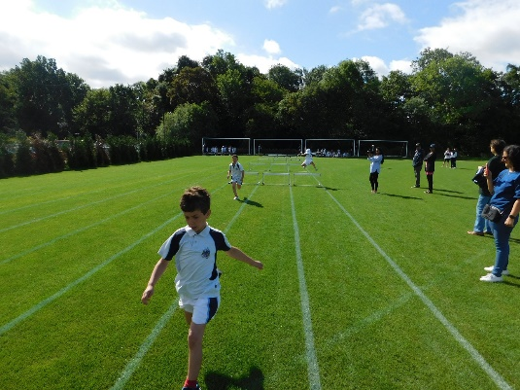
The School is oversubscribed and in September 2007 Governors opened a new Pre-Preparatory (Pre-Prep) School in an idyllic woodland setting just south of St Albans, six miles from the Prep and Senior School site. The Pre-Prep currently serves 72 boys aged from five to seven, in two Year 1 and two Year 2 classes.
Entry to The Pre-Prep is highly competitive and the standard of academic work is high. The curriculum is based on the Key Stage 1 National Curriculum which is enriched by additional materials, resources and the individual teacher’s personal knowledge and interests. The Pre-Prep staff frequently join staff from The Prep for professional training and there are regular meetings between The Pre-Prep Head and The Prep Subject Co-ordinators. The Pre-Prep make frequent visits to the Prep/Senior School site in Elstree for Games lessons and to join in various activities. It is expected that the Deputy Head (Pastoral) would work closely with the Head of Pre-Prep, who is line-managed by the Head of Prep School.

The Senior School
The Prep shares with The Haberdashers’ Aske’s Boys’ School (‘HABS’) its 100-acre rural site occupying the grounds of a former stately home, Aldenham House, a Grade 2* listed building. A series of magnificent new buildings have been opened in the last decade, including a £13m Sports Facility in 2016 and there are plans for considerable new investment in further development of the site.
HABS has an international reputation for academic excellence and success, combined with exceptional pastoral care and extra-curricular achievements. The school is regularly placed at the top of the national league tables, places are heavily oversubscribed, and entry is extremely competitive. Boys achieve national prominence in many fields, from music, drama and sport to science and Mathematics Olympiads, chess and public speaking.
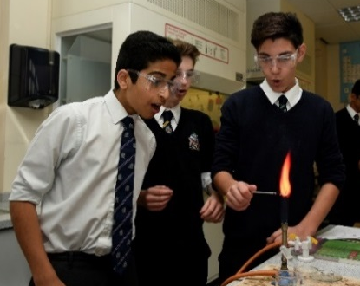
Pastoral care is exceptional, with a strong House-based system. Out-of-class activities abound, with many boys assuming responsibility for the running and organisation of events and societies. Music, drama and sport are strong, and there are also thriving Outdoor Leadership and CCF programmes together with a strong and active Community Service programme. There is a remarkable commitment to outreach and charity work, reflecting the rich and harmonious ethnic and religious diversity of the School. A Church of England School by tradition, other religious communities flourish with popular, voluntary assemblies on Thursday mornings for the many different faith groups which are represented in the School.

The School awards a number of scholarships on entry, but the majority of its funding goes into the provision of bursaries for cases of financial need, echoing the founding philosophy of Robert Aske. A very successful Development Foundation exists to broaden participation in the life of the School and encourage philanthropic giving.

Though the Prep is a distinctive entity from HABS Senior School, with its own DfE number and inspected separately, the Prep School is closely linked to the Senior School and it is the strategic intent of the Governors to increase those links. The Head of Prep serves on HABS’ Senior Management Team and is line-managed by the Headmaster.
More detailed information about the School and its history is available on the School website: www.habsboys.org.uk and through the Good Schools Guide www.goodschoolsguide.co.uk

The Teaching Staff
The members of the HABS Schools’ teaching staff are drawn from a wide range of backgrounds and reflect the diversity within the Schools. All are well qualified and have strong subject knowledge with a deep sense of commitment to the welfare of the boys and to help them achieve their very best. There is a strong sense of community within the Common Rooms, which are harmonious and dynamic places where staff work hard in a collaborative and purposeful atmosphere. There is a growing international dimension to the work of staff with regular visits overseas and links with the best schools across the globe.
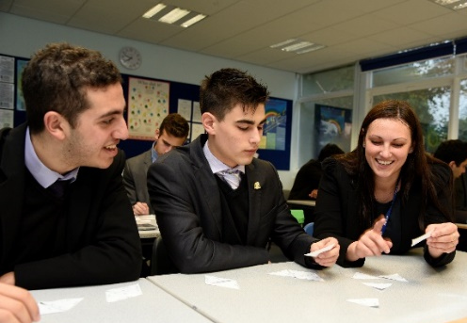
Support for staff at every stage of their career is exceptional, with one of the foremost and forward-thinking professional development plans in the country. Pedagogy and teacher development take a collaborative approach which is both voluntary and open-minded. Many teaching staff attend Learning Lunches where their peers will demonstrate new developments or ideas with which they have been experimenting. In addition, teachers can request specific training which is often run in well attended Twilight Training sessions at the end of a school day. The School operates an ‘open door’ approach with teachers regularly observing and learning from each other.
Every member of the teaching staff is expected to participate in the School’s rich array of co-curricular and sporting subjects. The main sports are rugby, hockey, football, athletics and cricket and the magnificent new swimming pool facility is raising the profiles of swimming and water-polo. Members of the teaching staff lead over 60 clubs and societies which include outreach programmes and charity fundraising projects. HABS will always encourage members of staff to share and support appropriate interests.

The Vacancy
The post will suit an inspirational, emotionally intelligent and impactful primary school leader who wishes to take the next step in their career. The successful candidate will have a passion for leading the development of character, experience in leading pastoral, welfare and safeguarding aspects of school life so that boys can thrive in a high achieving environment, and excellent understanding of primary school pastoral care in the modern world.
They will be able to:
- Participate in the strategic leadership and operational management of the school and in its development;
- Consider, recommend and implement innovations from research and practice to drive and enhance pastoral care;
- Take responsibility for all aspects of the Prep School’s safeguarding provision, in its policies, practices and documentation and to be the Prep School’s Designated Safeguarding Lead. In this role, the post holder will prepare a safeguarding update to be included in the Head of Prep’s Governors’ Report and work closely with the DSL of the Senior School who has overall responsibility for HABS’ Safeguarding;
- Support, coach, line manage, appraise and develop the Housemasters and all the Prep staff members in their pastoral duties and care for the boys;
- Design, develop and implement all Prep pupil disciplinary frameworks to include rewards and sanctions making sure it is consistent with the Senior School by liaising with the Deputy Head (Pastoral) of the Senior School;
- Lead and liaise with the Head and other members of staff as appropriate in the investigation of complaints from pupils, parents or staff.
The role holder is expected to demonstrate the following attributes:
- Experience of school management at a senior level within a highly successful independent preparatory school or state primary school;
- Outstanding teaching practice, with QTS, in any subject, as well as experience in leading and delivering pastoral/welfare requirements of bright, curious pupils;
- Genuine interest in developments in pastoral care in leading independent schools;
- A sharp intellect to dissect problems and the creativity and positivity to identify solutions;
- Excellent organisational skills, with a keen eye for detail and evidence of rigour in implementation and follow-through;
- The personal qualities and behaviours which will make them a role model of the school’s values for staff and pupils;
- Curiosity, team spirit, emotional intelligence, open-mindedness, initiative, resilience, flexibility and integrity.

This is an exciting time in the history of HABS, with a newly appointed Headmaster and Head of Prep, a strategic drive towards ever closer collaboration between their schools and also Haberdashers’ Aske’s School for Girls, which occupies the adjacent site, and the development of the Elstree campus over the next ten years. For this reason, candidates who are approachable, ambitious, creative, energetic and impactful will be particularly welcome.
Applications are invited from teachers in either the maintained or independent school sector.
The post holder will line-manage Housemasters and will be line-managed by the Head of the Prep,
for whom they might be expected to deputise on a regular basis.
The successful candidate will be expected to teach a portion of a timetable, and to contribute to the co-curricular programme. The nature of this post might require the successful candidate to be present at the Prep and Pre-Prep before and beyond the timetabled day, and to provide active support for all the regular occasions of School life e.g. social functions, sports events assemblies.

Principal Duties
To be read in conjunction with the terms of employment.
The Deputy Head (Pastoral) will be a member of the Prep Leadership Team (‘PLT’) and hold broad operational and strategic responsibility for the management of the Prep, its development and delivery of welfare and pastoral matters. The Deputy Head (Pastoral) may be asked to deputise for the Head of the Prep and will be expected to work seamlessly with The Deputy Head (Academic).
The responsibilities of this post are likely to include, but are not restricted to:
Strategic School Aims and Objectives
- In consultation with the Head of the Prep, lead and model the pastoral vision for the Prep;
- Consider, recommend and implement innovations from research and practice to drive and enhance pastoral care;
- Be the DSL for the Prep School, working closely with the DSL of the Pre-Prep and providing regular information and reports to the HABS DSL;
- Work closely with the rest of the Prep Leadership Team (‘PLT’) to develop and monitor the strategic direction of the Prep School, also collaborating with colleagues in the Senior School and Girls’ School to ensure a shared vision;
- Assist in the preparation, promotion and implementation of School policies;
- In conjunction with PLT and all members of the School’s staff, be responsible for discipline and behaviour in the Prep and the Pre-Prep;
- Be prepared to participate in the interviewing of staff and pupils;
- Ensure that the PLT is aware of current ISI requirements.

Staff Development
- Be a role model for pupils and colleagues, promoting school values and ensuring that staff uphold the school’s ethos through their styles of communication with pupils and parents
- Lead colleagues on the wellbeing and character development of the pupils by promoting the House system which is the vertical, pastoral scaffolding of the School.
- Contribute positively to the staff’s and their own annual review and performance management
- Promote and endorse a leadership skills development programme which the School is looking to implement from September 2020; model leadership and management skills to support and enhance the programme.

Pupil and Staff Welfare
- Oversee, advise, assist and direct as necessary in the planning, timing and attendance at the key events in the Prep year, demonstrating a clear understanding of and commitment to Prep and HABS priorities and the fair and appropriate division of work;
- In collaboration with HABS’s Deputy Head (Staff), ensure the wellbeing of staff in the Prep School;
- Provide advice to colleagues on matters relating to pupil and staff welfare;
- Lead on strategies for addressing issues associated with attendance, absence and persistent absence in both the pupil and staff communities; monitor pupil and staff behaviour patterns;
- Lead and manage the pupil disciplinary processes and ensure appropriate and accurate records are kept;
- Promote the educational welfare of each pupil within the Prep and encourage positive behaviour from every member of the Prep community;
- Implement and oversee pupil mentoring/buddy system;
- Work closely with colleagues in the Senior School and other schools to ensure the older boys are ready for their transition to senior school, whether HABS or elsewhere.
Any other reasonable and related activities at the discretion of the Head of the Preparatory School or the Headmaster.

Salary and Benefits
The School has its own generous salary scale, supplemented by a performance-related scheme. The salary for the successful candidate will depend upon their qualifications and experience and will be discussed at interview.
Candidates should note that all appointments are subject to an enhanced check with the Disclosure & Barring Service and references from past employers.
Benefits
Currently the School offers a wide range of benefits to teaching staff, including:

- A strong commitment to professional development, with a substantial budget for whole school training and individual courses. Support is given for sabbaticals, post-graduate degrees and other relevant qualifications;
- Membership of the Teachers’ Pension Scheme (TPS);
- Group Life Assurance (4 x salary);
- Fee Remission of 66% for each eligible child at the Boys’ and Girls’ Schools who is offered a place;
- Reimbursement of relocation expenses;
- Childcare Vouchers;
- Free sports clothing for those taking games;
- Free lunches, other meals and refreshments;
- Free parking on the School campus;
- Free coach travel on the service provided by the School (subject to availability);
- Free use of a laptop computer or tablet device;
- Tax free bicycles for work through the Cycle to Work Scheme;
- Free use of the state-of-the-art Medburn Centre including fitness suite, swimming pool and squash courts, including free training programmes and advice from the School’s Fitness Coach;
- Access to the School Counsellor.

We look forward to receiving your application.
Matteo E Rossetti
Head of Prep School

