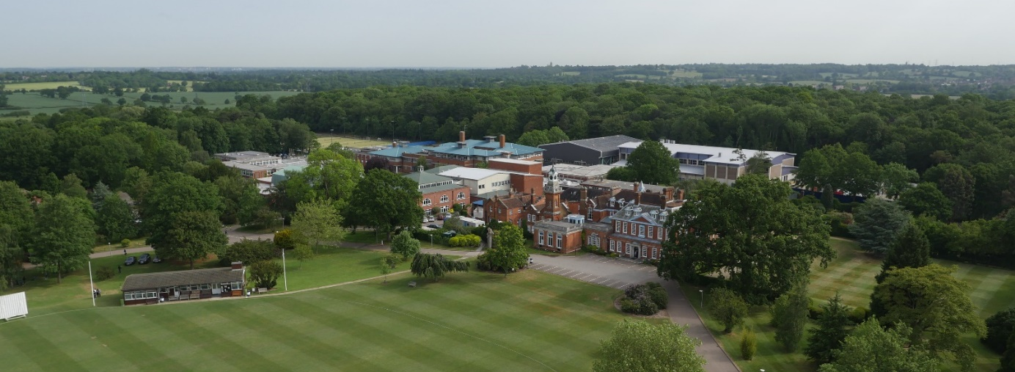

Senior Deputy Head – September 2019
Following the promotion of the former Second Master to the headship of an HMC School, we are seeking an inspirational school leader who will ‘nurture excellence’ in our pupils.
The Senior Deputy Head will deputise for the Headmaster in his absence and will advise the Headmaster on all aspects of school life. They will be responsible for the smooth day-to-day running of the Senior School and for ensuring that pupil behaviour is exemplary at all times. They will report to the Headmaster and be a member of the Senior Leadership Team, playing a key role in whole school strategic and operational leadership.
Applicants should be good honours graduates of a leading university, have experience of leading and managing in a successful school environment and be willing to be fully involved in all aspects of the school's busy life. Some teaching is envisaged, but no specific specialist subject is sought. A willingness to contribute to the School’s extensive co-curricular programme is also required.
The post would suit an ambitious candidate aspiring for a future headship.

Applications
An application form is available from the School’s website: www.habsboys.org.uk. Curriculum Vitae are not accepted.
The completed application form should be sent to the Human Resources Director (staffvacancies@habsboys.org.uk) as soon as possible (preferably electronically). It must be received no later than noon on Friday 25th January.
We intend to hold first round interviews for this post on Thursday 7th February, with final round interviews on Wednesday 13th February.

The School
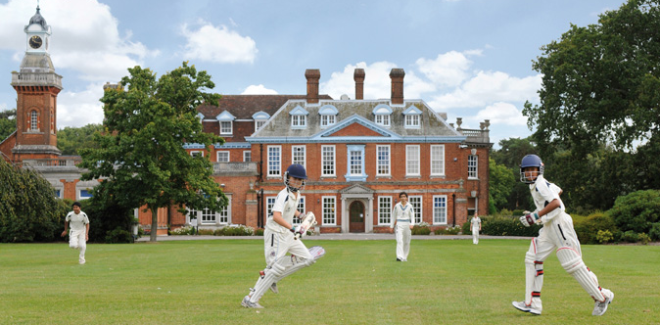
The Haberdashers’ Aske’s Boys’ School (‘HABS’) has an international reputation for academic excellence and success, combined with exceptional pastoral care and co-curricular achievements.
The School is an independent day school with around 1,200 11–18-year-old boys in the Senior School and another 200 boys from the age of 7 in the Preparatory School, which is situated on the same site. A Pre-Prep School for 75 boys aged 5 and 6 is located nearby. The School’s grounds adjoin those of its sister school, the Haberdashers’ Aske’s School for Girls and an extensive and long-established coach service brings pupils and staff from across a wide area.
HABS removed to its current 100-acre rural location in 1961, occupying the grounds of a former stately home: Aldenham House, a Grade 2* listed building, located 15 miles North of the centre of London. A series of magnificent new buildings have been opened in the last decade including a new £13m Sports Facility in 2016. The construction of a state-of-the-art classroom complex at the heart of the campus, specifically designed to reflect international best practice in school design and pedagogy will open in the near future.
HABS’ aim is to nurture excellence within its established values of wisdom, integrity and humility. ISI have graded the School as outstanding in all aspects. The members of the teaching staff are united by a caring approach, passion for their subject areas and the aspiration to be dynamic, modern and reflective practitioners.
Examination results are outstanding placing the School 7th in the UK League tables; places are heavily oversubscribed; and entry is extremely competitive. Boys achieve national prominence in many fields from music, drama and sport to science and Mathematics Olympiads, chess and public speaking.
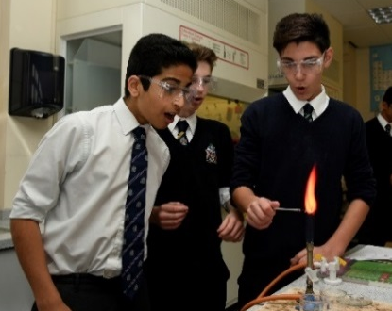
The current intake of boys is exceptional, and the School has been placed at the top of the national league tables. Education at HABS, however, is about more than just academic success. The boys are bright, articulate and open, interested and extremely rewarding to teach. They have a great sense of humour and are very well mannered.
Pastoral care is exceptional, with a strong House-based system. Out-of-class activities abound, with many boys assuming responsibility for the running and organisation of events and societies. Music, drama and sport are strong, and there is also a thriving Outdoor Leadership programme and CCF together with a strong and active Community Service programme. HABS’ boys regularly reach the finals of national competitions, such as chess, bridge and debating, but there is also a remarkable commitment to outreach and charity work, reflecting the rich and harmonious ethnic and religious diversity of the School. A Church of England School by tradition, other religious communities flourish with popular, voluntary assemblies on Thursday mornings for the many different faith groups which are represented in the School. This approach to all faiths was highly commended in the current ISI inspection report.

The School awards a number of scholarships on entry, but the majority of its funding goes into the provision of bursaries for cases of financial need. A very successful Development Foundation exists to broaden participation in the life of the School and encourage philanthropic giving.

More detailed information about the School and its history is available on the School website: www.habsboys.org.uk and through the Good Schools Guide www.goodschoolsguide.co.uk

The Teaching Staff

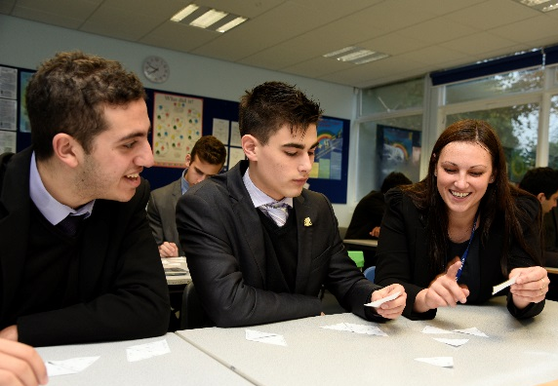
The members of the Teaching Staff are drawn from a wide range of backgrounds and reflect the diversity within the School. All are well qualified (but not necessarily with a formal teaching qualification) and have strong subject knowledge with a deep sense of commitment to the welfare of the boys and to help them achieve their very best. There is a strong sense of community within the Common Room and it is a harmonious and dynamic place where staff work hard in a collaborative and purposeful atmosphere. There is a growing international dimension to the work of staff with regular visits overseas and links with the best schools across the globe.

Support for staff at every stage of their career is exceptional, with one of the foremost and forward-thinking professional development plans in the UK. Pedagogy and teacher development take a collaborative approach which is both voluntary and open-minded. Many teaching staff regularly attend Learning Lunches where their peers will demonstrate new developments or ideas with which they have been experimenting. In addition, teachers can request specific training which is often run in well attended Twilight Training sessions at the end of a school day. The School operates an ‘open door’ approach with teachers regularly observing each other and learning from their colleagues.
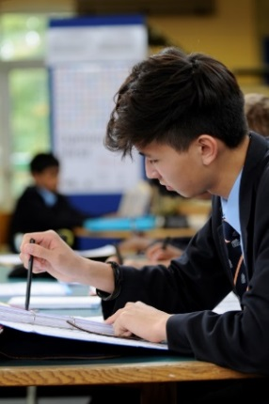
Every member of the teaching staff is a form tutor and is expected to participate in the School’s rich array of co-curricular and sporting subjects. The main sports are Rugby, Hockey, Soccer, Athletics and Cricket and the magnificent new swimming pool facility will raise the profiles of Swimming and Water-Polo. There is a sixth form Enrichment and Enhancement programme within which members of staff are encouraged to share a personal academic interest, pastime or pursuit. The list of available subjects ranges from Geology to Salsa dancing with a gamut of topics in between. Members of the teaching staff lead over 60 clubs and societites which include outreach programmes and charity fundraising projects. HABS will also find ways to encourage members of staff to share and support appropriate interests.

Newly Qualified Teacher Programme
The School is committed to providing high quality training and support to newly qualified teachers (NQTs). Working in partnership with The Independent Schools Teacher Induction Panel (IStip), the School expertly guides them through their induction year with experienced mentoring from a departmental colleague, and offers ongoing opportunities for lesson observation and pedagogical debate. The School is a centre of excellence for training: we host regular regional conferences where we welcome NQTs from across London and Hertfordshire to participate in professional studies programmes designed by HABS’ staff. Our NQTs experience a rich, varied teaching experience during the first year of their careers, giving them the confidence and expertise to become highly effective, reflective classroom practitioners.

The Vacancy
The post will suit an exceptional individual with a strong track record in leadership and management in schools. They will be an excellent administrator and communicator with the ability to show initiative and work well within a team. The Senior Deputy Head will make a significant contribution to the school’s strategic development, and to the smooth day-to-day operation of the school. Further areas of responsibility will be shaped in response to the skills, interests and experience of the candidate.
The successful candidate will be expected to lead by example, demonstrating the School’s values in all that they do. They will also teach a portion of a timetable (no specific subject specialism is sought), contribute to and support our vibrant co-curricular programme.
This is an exciting time in the history of Haberdashers’, with a newly appointed Headmaster and Head of Prep, a strategic drive towards ever closer collaboration between the school and Haberdashers’ Aske’s School for Girls, which occupies the adjacent site, and the development of the Elstree campus over the next decade. The post offers the right candidate an outstanding opportunity to have a significant impact on the future of the School and will be attractive to someone planning to move to a Headship after a period of service at Haberdashers’.

Principal Duties
The Senior Deputy Head will deputise for the Headmaster in his absence, has responsibility for the day-to-day running of the Senior School and ensuring that pupil behaviour is exemplary at all times. They will report to the Headmaster and be a member of the Senior Leadership Team, playing a key role in whole school strategic and operational leadership.
The responsibilities of this post are likely to include, but are not restricted to:
School Leadership
- Be the principal advisor to the Headmaster on all aspects of school leadership and management
- Deputise for the Headmaster as required
- Contribute to and support the Headmaster’s vision for the school
- Assist in the construction and implementation of the School Development Plan
- Assist with major development projects
- Oversee collaboration with Haberdashers’ Aske’s School for Girls
- Assist the Headmaster in the appointment of staff
- Be a member of the Senior Leadership Team
- Attend and chair other school meetings, as appropriate
- Attend Governors’ meetings as required
Operational Management
- Be responsible for the day-to-day management of the Senior School
- Plan and manage major school events
- Oversee the school calendar, the start and end of term, set term dates
- Develop, implement and support school policies and procedures
- Planning, review and evaluate ISI Inspections
- Share responsibility as emergency contact for trips and excursions
- Lead on whole school disaster planning and fire drills
- Assist in disciplinary procedures relating to both teaching and non-teaching staff
- Liaise with support staff managers concerning the management of facilities and estates
- Assist in the creation of school budgets and be in financial control of budgets
Pastoral Care and Behaviour Management
- Ensure the maintenance of high standards of behaviour, punctuality and appearance
- Management of the rewards and sanctions systems
- Oversee the School Rules and School uniform policy
- Oversee the appropriate handling of any serious pupil disciplinary matters
- Help to appoint, train and manage the team of Prefects
- Work closely with the Deputy Head Pastoral, Heads of Section and other pastoral staff
- Act as a Deputy Designated Safeguarding Lead, working closely with the DSL

Person Specification
- Natural leadership qualities, combining humility with a sense of credibility and presence
- A commitment to educational excellence
- Capacity for hard work and handling stressful situations with energy, enthusiasm and a positive outlook
- The ability to motivate and inspire
- A team player with an ability to develop and to sustain relationships and empower others
- The wisdom and ability to resolve complex problems
- A capacity to initiate and manage change with flair and creativity
- Integrity, reliability and a commitment to honesty and fairness
- A sense of humour
Education, Qualifications and Skills
- A good bachelor’s degree
- Qualified Teacher Status (QTS) is desirable, not essential
- An excellent record as a teacher, manager and leader
- A record of continuous professional development
- Excellent communication and listening skills
- Powers of diplomacy and persuasion
- The ability to think strategically and to contribute towards the School’s development
- Strong organisational and administrative skills with a keen eye for detail
- A good level of IT competency
Knowledge and Experience
- A track record of outstanding leadership and management in education
- A holistic view of education that encompasses academic, pastoral and co-curricular elements
- Experience of managing change
- Understanding of role in the context of safeguarding children
- Understanding of the requirements of Equality and Diversity
Salary and Benefits
The School has its own generous salary scale, supplemented by a performance-related scheme. The salary for the successful candidate will depend upon their qualifications and experience and will be discussed at interview.
Candidates should note that all appointments are subject to an enhanced check with the Disclosure & Barring Service and references from past employers.
Benefits
Currently the School offers a wide range of benefits to teaching staff, including:
- A strong commitment to professional development, with a substantial budget for whole school training and individual courses. Support is given for sabbaticals, post-graduate degrees and other relevant qualifications;
- Membership of the Teachers’ Pension Scheme (TPS);
- Group Life Assurance (4 x salary);
- Fee Remission of 66% for each eligible child at the Boys’ and Girls’ Schools who is offered a place;
- Reimbursement of relocation expenses;
- Childcare Vouchers;
- Free sports clothing for those taking games;
- Free parking on the School campus;
- Free coach travel on the service provided by the School (subject to availability);
- Free use of a laptop computer or tablet device;
- Tax free bicycles for work through the Cycle to Work Scheme;
- Free use of the state-of-the-art Medburn Centre including fitness suite, swimming pool and squash courts, including free training programmes and advice from the School’s Fitness Coach;
- Access to the School Counsellor.
- Free lunches, other meals and refreshments

We look forward to receiving your application.
Gus Lock
Headmaster

